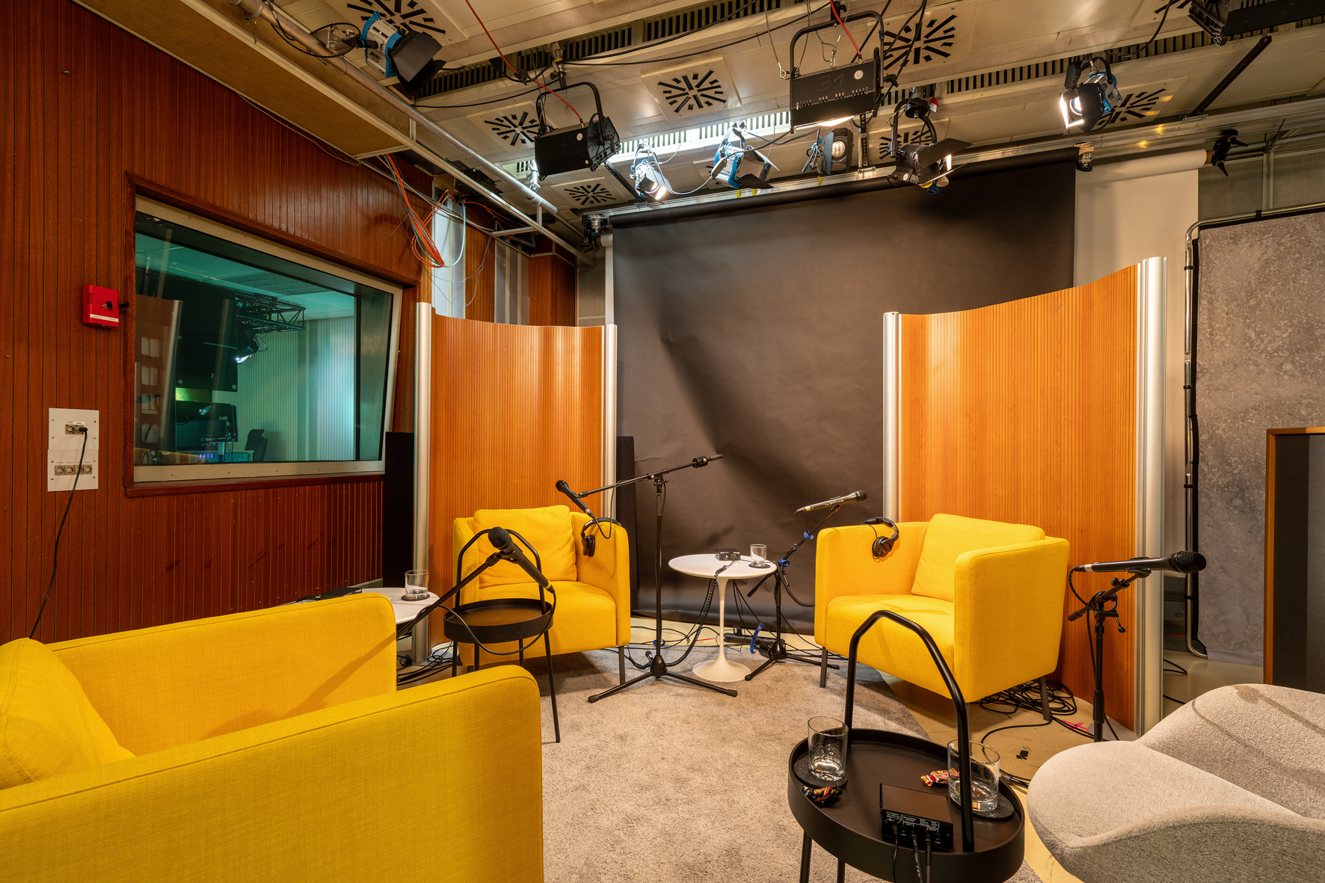

TVN Corporate Media
Award-winning podcast production with Sennheiser microphones

Wedemark/Hannover, July 2024 – With their constantly growing fan base, podcasts are highly relevant in today’s media landscape. Companies, too, have long since discovered this medium as a means to provide insights into their corporate world and topics. However, not all businesses are able to or want to produce podcasts completely on their own. This is where professional partners such as TVN Corporate Media GmbH & Co. KG (tvn-cm.de/en) come into play.

TVN Corporate Media, which is part of the TVN Group, has been successfully active in the field of audiovisual production for many years. Where required, they will provide support for companies as a full-service partner throughout the entire podcast production process. Rolf Rosenstock, Creative Director Corporate Audio: “Our services range from format coordination and the selection of topics and hosts, including booking and contract management, to complete production processes, including sound design, creation of the cover image and publication on target platforms. We create distinctive identities that match the individual concept: intros, outros, stingers and jingles.”

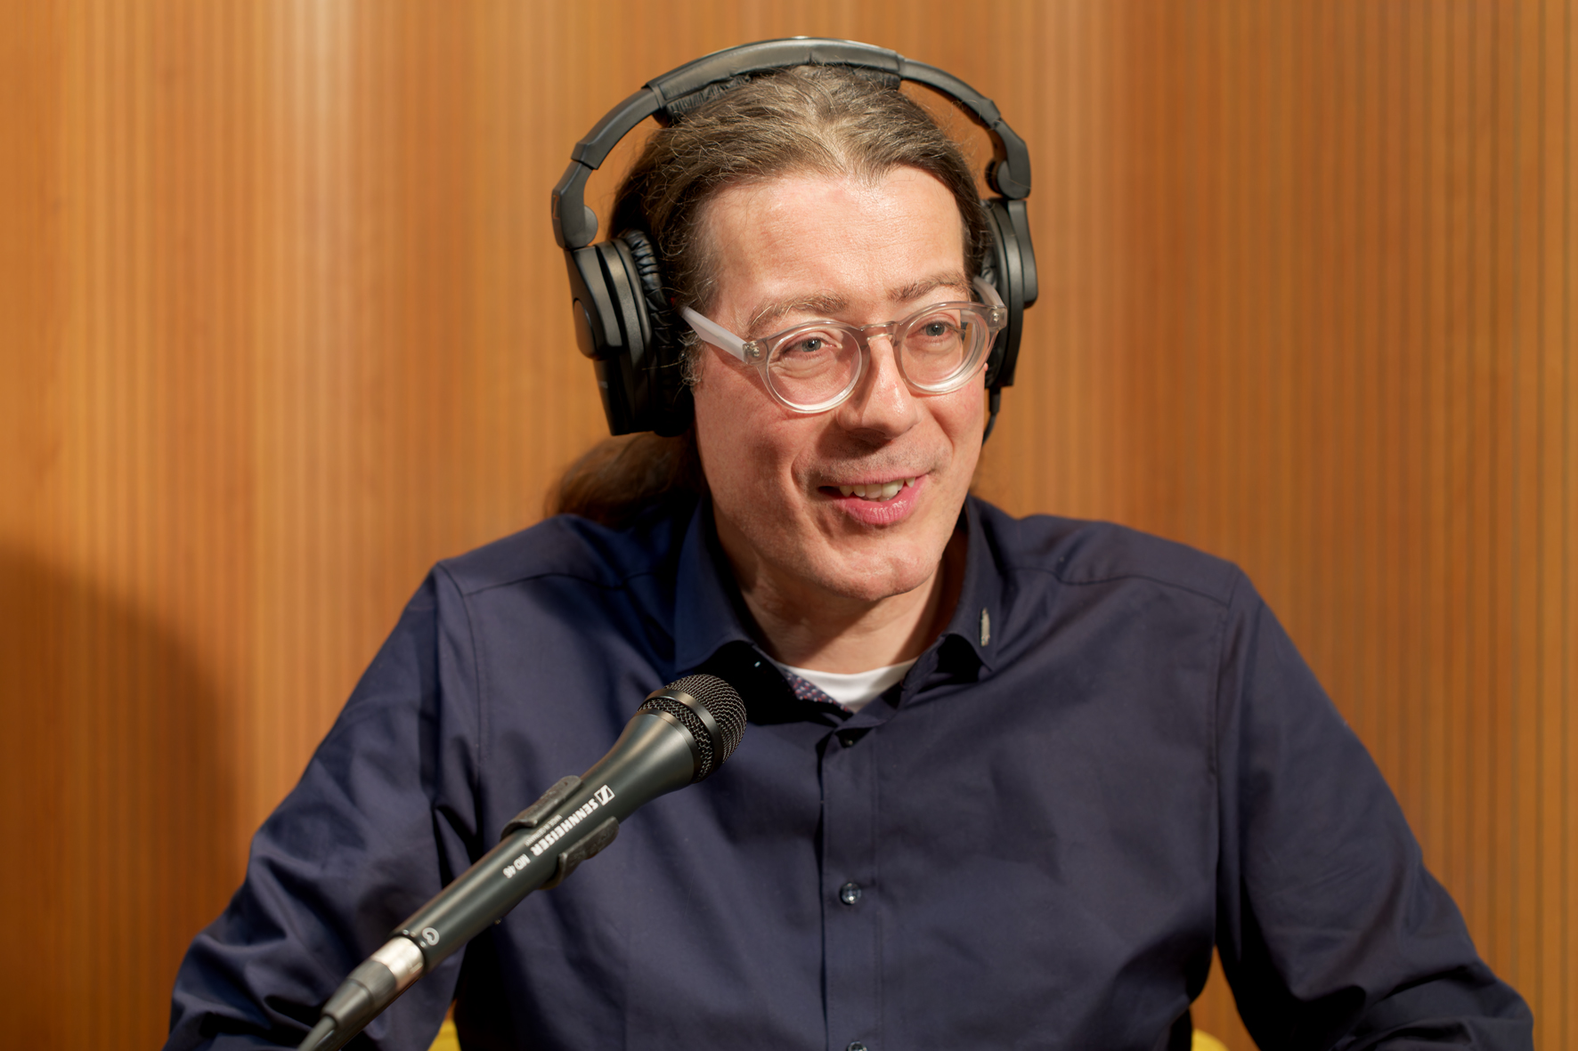 | Creative producer Rolf Rosenstock works as a host in the podcast studio and always does his best to make his guests feel comfortable

TVN Corporate Media is responsible for award-winning podcast productions, including a true crime podcast series for the daily newspaper “Neue Presse” from Hannover, which focuses on real and sometimes unsolved criminal cases from the region around Lower Saxony’s capital city. With five seasons to date, the series has had more than 900,000 downloads/streams and has held top positions in the genre charts on Apple and Spotify.

Mixing, mastering and murderers
At the end of April 2024, the sixth season of “True Crime Hannover” was recorded at a TVN Group studio in Hannover. The format, which won the Lower Saxony Media Award in December 2023, is the most successful podcast of the Madsack Mediengruppe, which owns the “Neue Presse” and TVN Group Holding GmbH & Co. KG with its subsidiaries. “True Crime Hannover” has been in Apple’s genre charts continuously for three years now.

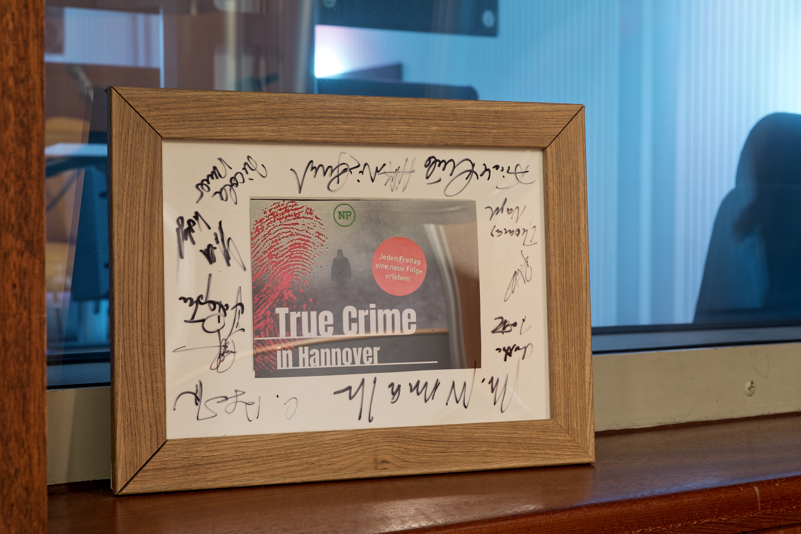 | The “True Crime Hannover“ format, which won the Lower Saxony Media Award in December 2023, is Madsack Mediengruppe’s most successful podcast

All seasons, each of which has six episodes, were conceived, written, recorded, mixed, mastered and published by TVN Corporate Media under the directorship of Rolf Rosenstock. In the five seasons that have been produced since autumn 2021, “Neue Presse” employees talk about true criminal cases from the Hannover region. Regular guests in the studio include lawyers, forensic doctors, police officers and psychiatrists, who use their expertise to put even the most unusual human dramas into perspective and contribute qualified information from their respective fields.

One of those supporting Rosenstock in producing the podcast is post-production specialist Alexander Kollmeyer, who has worked at TVN since 1996. Kollmeyer has his workplace in the company’s multifunctional sound studio located in the well-known Anzeiger office block in Lower Saxony’s state capital. The control room is equipped for Dolby Atmos productions and has a 5.1.4 loudspeaker setup, including an elevated playback level. The equipment installed includes nine bi-amplified Neumann KH 120 two-way monitors with integrated class-AB amplifier modules, which ensure reliable assessment of the sound quality. However, in the studio, the podcasts are mixed in stereo rather than in multi-channel processes such as Dolby Atmos or Auro-3D.

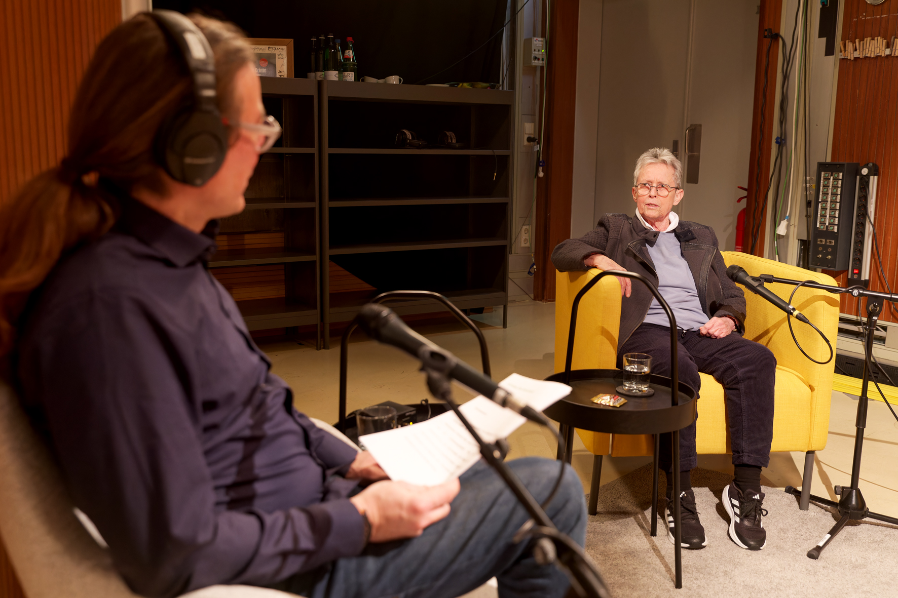 | A guest in the studio: Monika Freckmann worked at Lower Saxony’s LKA (Criminal Police Office) for more than three decades as a soil analysis expert. “Dirt is my life,” says the retired forensic scientist jokingly. As a trained chemical laboratory technician, Freckmann has helped to convict many criminals in her professional career thanks to her meticulous soil analysis. In the past, she would probably have been called a “tracker”

For the podcasts, the speakers’ voices are picked up using dynamic Sennheiser MD 46 reporter’s microphones and are pre-amplified with external pre-amps before being transmitted via high-quality converters with a bit depth of 24 bit and a sample rate of 48 kHz to a professional DAW, where the recording is made. Mixing and mastering are carried out “in the box” using various plug-ins without additional peripheral equipment. The result is a high-quality WAV file, which is subsequently converted into a suitable format for the respective podcast distribution platforms.

A relaxed studio atmosphere: just like in a living room …
Mobile dividing walls, soft furniture and carpets are used in the recording studio to create a pleasant living room atmosphere for the podcasts. “We want our guests to feel comfortable. After all, these are not studio professionals, but people who rarely have to deal with recordings and might sometimes be a bit nervous,” explains Rosenstock. “It was therefore all the more important for us to create an atmosphere for the speakers to have a relaxed conversation – and this ultimately benefits their performance. Soon after they start talking, most guests have already forgotten that they are being recorded.” From a sound engineering perspective, dividing walls, soft furniture and carpets produce “dry” room acoustics, and this helps to provide good speech intelligibility.

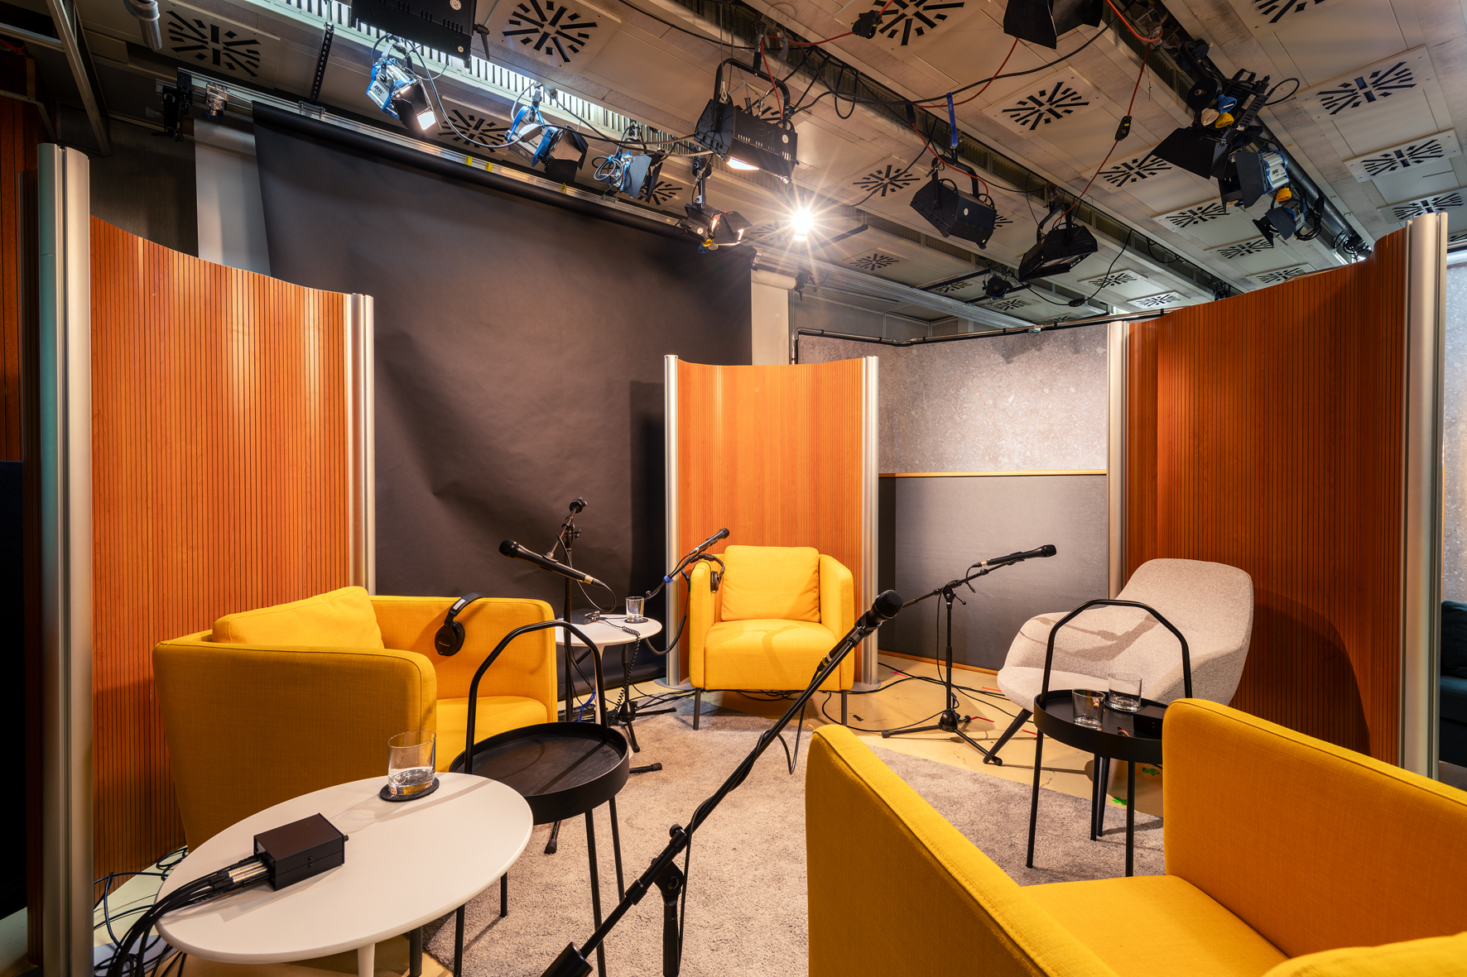 | The recording studio has a relaxing atmosphere

The fact that the same microphone type is used for all guests is a deliberate decision, as audio specialist Alexander Kollmeyer explains: “Each type of microphone has its own characteristics, and I want to ensure that all persons are treated equally in terms of acoustics and that no-one is given preference based on the sound of their microphone. In podcast recordings, I’m not a fan of the proximity effect and I attach great importance to making the recording sound as natural as possible, which, in my opinion, can also include the occasional slight background noise. If everything is ruthlessly ‘ironed out’ during post-production, the overall sound can seem too sterile. For podcasts, I don’t try to achieve a typical radio sound, which to a certain extent is a matter of taste. Personally, I just don’t like it when the bass components of voices are over-emphasised when people are speaking.”

Kollmeyer continues: “We don’t have trained speakers with professional microphone discipline in the studio for our podcasts. Our guests often move around quite naturally in their armchairs, which means that the distance between their mouth and the microphone is constantly varying. If we used the type of close-miking that is common in radio broadcasting, that would lead to problems.”

Rosenstock adds: “For me as a host, it’s important that I can focus entirely on the conversation and my guests. I don't want to have to worry about whether the sound is OK. At TVN, we are committed to providing the best possible sound quality – and our customers expect that, too. I’m really pleased to have a proven expert like Alexander Kollmeyer at my side for the production of our podcasts.”

Post-production specialist Alexander Kollmeyer is responsible for good sound in the studio | 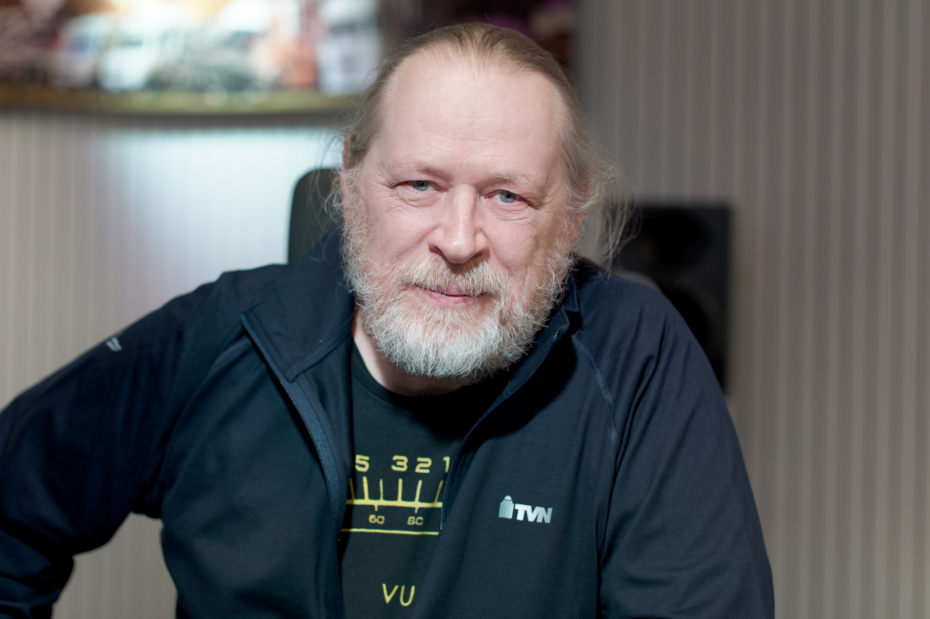

Professional podcast recording with Sennheiser MD 46
Kollmeyer is in the comfortable situation of having access to an extensive pool of microphones, all of which can be flexibly used within the TVN Group. A large number of Sennheiser microphones are available for outside broadcasting for TVN Live Production GmbH, including a lot of MKH condenser models and “classic” dynamic microphones such as the MD 441-U or MD 421-II. Various Neumann microphones are also available for all kinds of applications. “When I’m working in the studio with professional speakers, I always like to use large-diaphragm microphones such as the Neumann U 87 Ai or a model from the Neumann TLM series “, says Kollmeyer. “But for the podcast production, I deliberately chose the Sennheiser MD 46, because it’s perfectly suited for this job.”

The Sennheiser MD 46 is a high-quality dynamic microphone with a cardioid pick-up pattern that was specially developed for rough use in live reporting and is very popular on radio and television, especially because it offers an impressively high level of speech intelligibility even in noisy environments. The MD 46 has a relatively long shaft and is easy to handle, as its special design effectively avoids problems with wind and structure-borne noise. A robust two-ply stainless-steel sound inlet basket protects the shock-mounted capsule. The frequency response of the MD 46 extends from 40 Hz to 18 kHz.

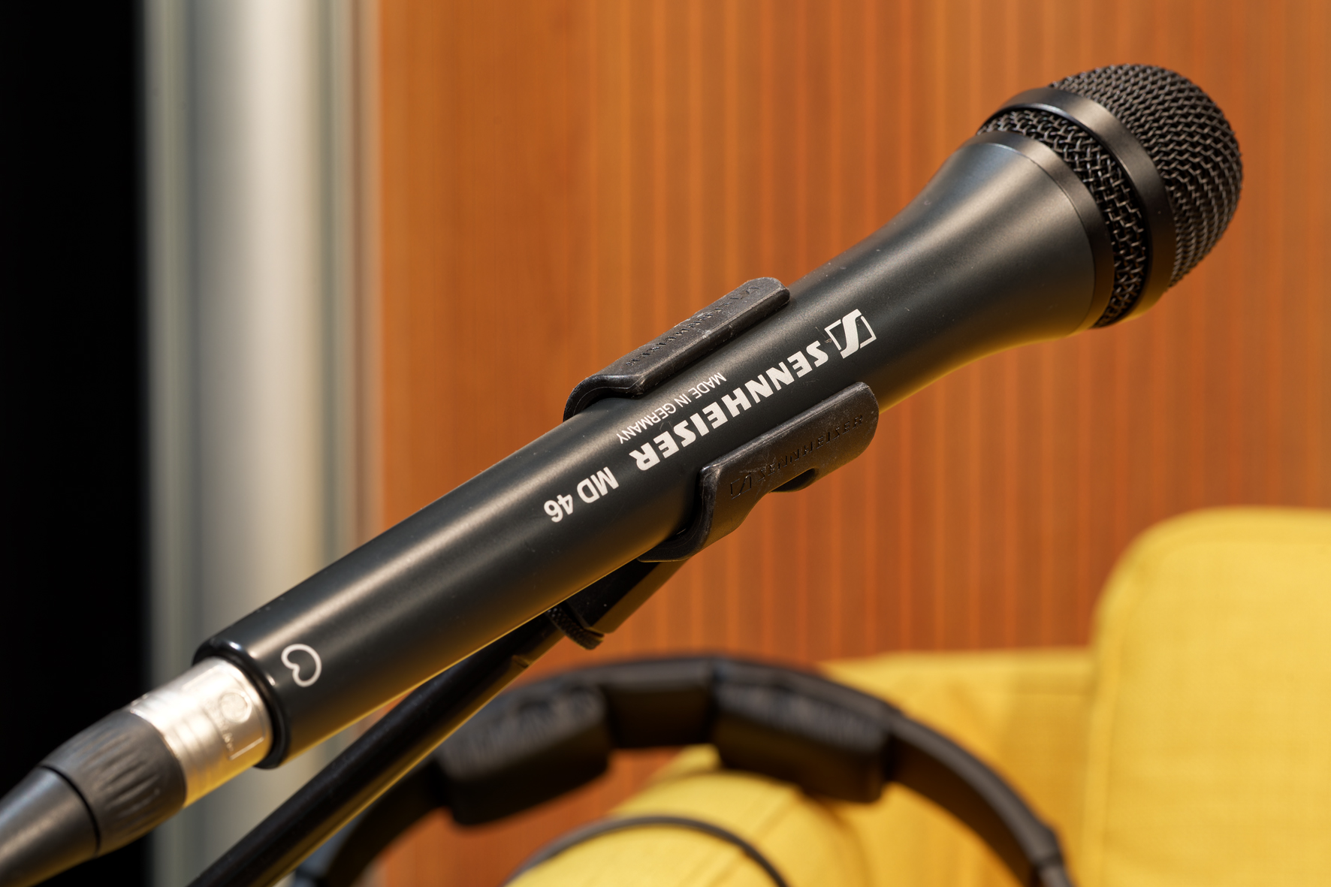 | For the podcasts, the speakers’ voices are recorded using dynamic Sennheiser MD 46 microphones

Kollmeyer has been using Sennheiser products for more than 30 years and is convinced by their proverbial quality and reliability. He says: “I have a musical background and still play drums in a band. I’ve been able to gain a lot of experience with Sennheiser microphones over the past three decades and these were always positive in very different contexts. My band was supported early on by Michael Polten, who at that time was head of the Music Industry team at Sennheiser. I can still clearly recall the first time I put on a pair of closed Sennheiser HD 25 headphones, which immediately became my favourite model – I ended up wearing them all the time! They were incredibly loud and exactly the right thing for me as a drummer … (he laughs). With Sennheiser, I know that I can rely on the technology and always get good sound results.”

For podcast productions, guests in the TVN studio not only use microphones from Sennheiser. They can, if they want to, also put on closed Sennheiser HD 280 PRO headphones, which are very comfortable to wear with their soft ear pads and are easy to handle with their single-sided cable. These dynamic around-the-ear stereo headphones feature highly detailed, linear sound reproduction and good attenuation of ambient noise.

True crime podcasts – harmless listening enjoyment?
The true crime genre is extremely popular in the podcast landscape. With exciting and sensational, sometimes even sensationalist, stories about true crimes and mysterious criminal cases, True Crime podcasts attract a wide audience. “Evil is all around us” is the unwritten headline.

Podcasts like these have often tended to focus on the victims and their families, without giving due consideration to their privacy and their suffering. What is more, the selection of cases and the way that they are presented runs the risk of producing a tendentious image of crime. This type of selective representation can promote stereotypes and misconceptions about crime and create a narrative that suggests that the victims themselves are responsible for their situation (“victim blaming”).

TVN Corporate Media is well aware of this problem. Rosenstock explains: “Of course, we at TVN asked ourselves how we could do it differently and better. For that reason, we invite experts who can put the topic into the right perspective. We also provide information on where victims can find help and support, and it is often the case that we have family members as guests who are prepared to talk openly about their feelings. It is clear that, with a topic like this, we also have to examine the psyche of the perpetrators, but this perspective is not our main focus. We prefer to put detailed questions to an investigator who can shed some light on the matter or who perhaps even helped to successfully solve a case.”

(Ends)

The images in this press release can be downloaded here.

About TVN CORPORATE MEDIA
TVN CORPORATE MEDIA designs and creates customised solutions for all corporate communication challenges. These include innovative and measurably successful communication strategies with a focus on moving-image content. Their approach is to understand and achieve a client's goals through holistic campaigns across all channels. TVN CORPORATE MEDIA is a long-standing agency partner of commercial enterprises and public institutions, and is part of the TVN GROUP.
tvn-cm.de/en

About the Sennheiser Group
Building the future of audio and creating unique sound experiences for our customers - this is the aspiration that unites the employees of the Sennheiser Group worldwide. The independent family-owned company Sennheiser was founded in 1945. Today, it is managed in the third generation by Dr. Andreas Sennheiser and Daniel Sennheiser, and is one of the leading manufacturers in the field of professional audio technology.
sennheiser.com | neumann.com | dear-reality.com | merging.com

Global pro audio press contact
Stephanie Schmidt
stephanie.schmidt@sennheiser.com
+49 (0)5130 600-1275

